WEEK 2
- What number is missing from this number sentence?
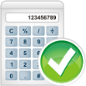
5 × + 15 = 85
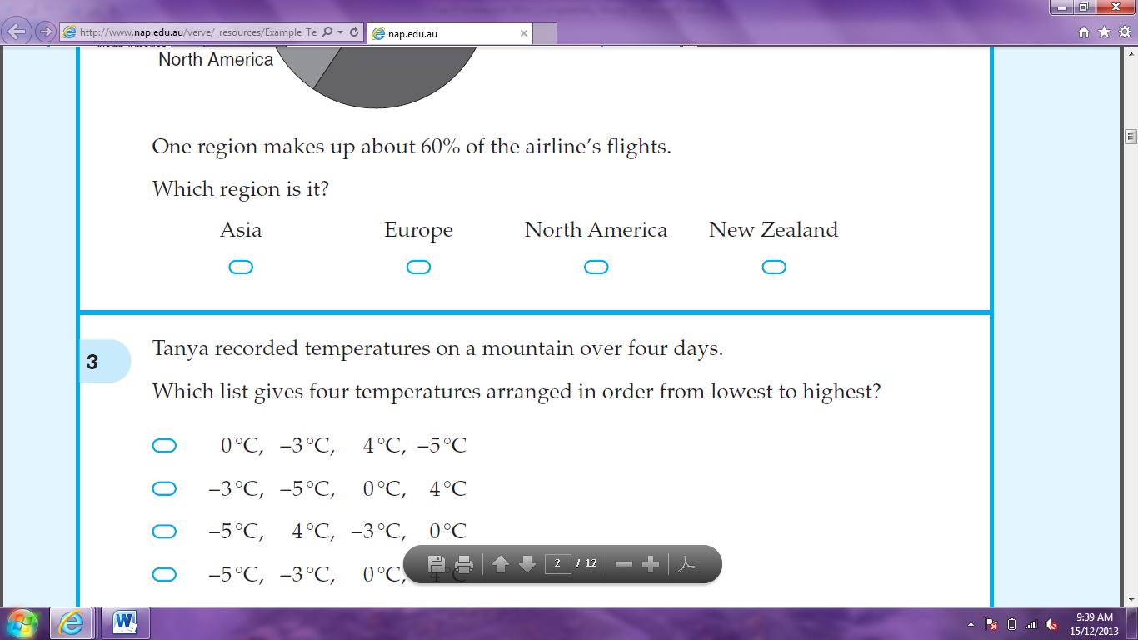



2 10 14 20

- Jane bought a packet of twleve cards for $15. The average price of a card is:




$0.80 $1.25 $1.80 $3.00

- A rule for a pattern is: ‘double the previous number and add 3’. The first number in the pattern is 1. What is the fourth number?

- A rule for y in terms of x is y = 4x + 3. What is the value of y when x = 2?

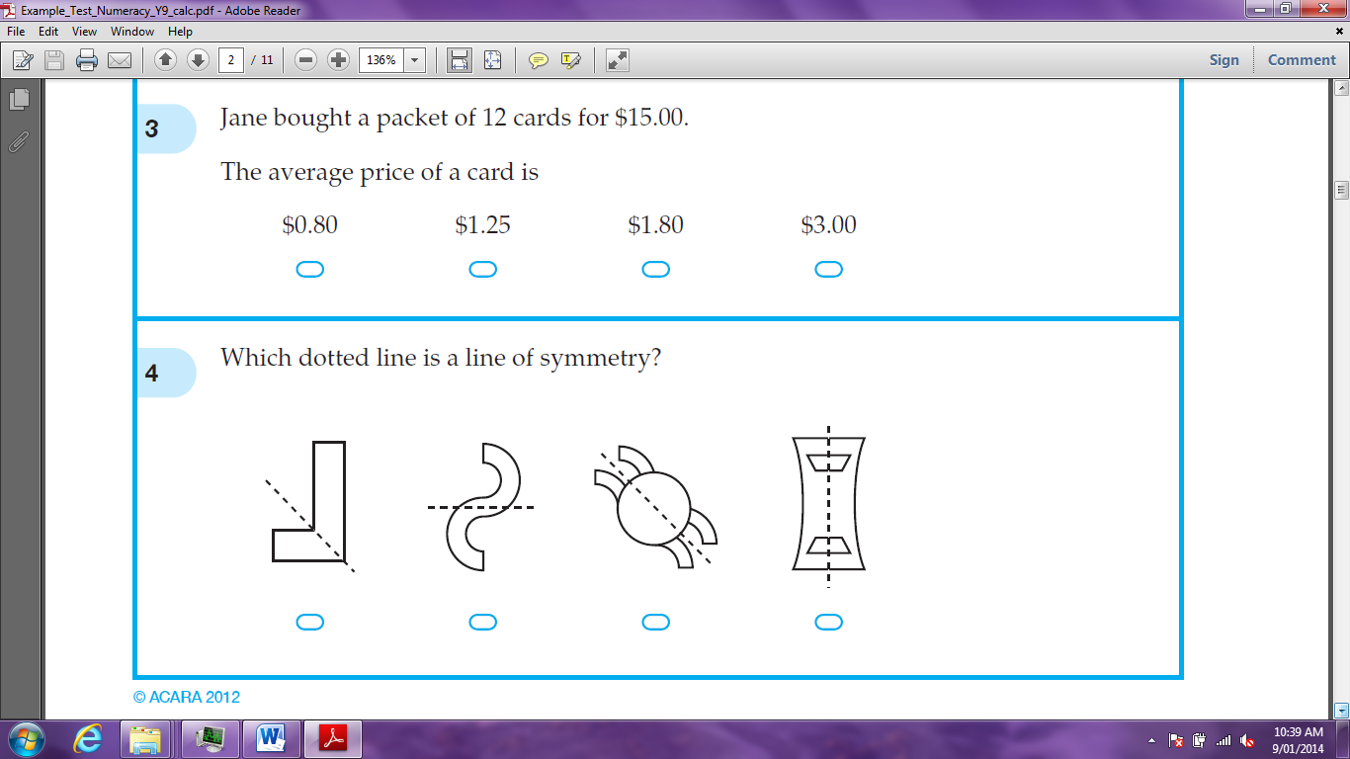
- Which dotted line is a line of symmetry?




The diagram shows the top view of a solid. What is the solid?





Square Prism Square Pyramid Triangular Prism Triangular Pyramid
- Which rectangle has the largest area?






- The train arrived at the station at 2:38pm and left at 3:11pm. How many minutes was the train at the station?

- Jon checked 60 players in his club to see if they had paid their fees. The results are shown in the table.
 | Paid | Unpaid
Seniors | 8
Juniors | 22 | 13

How many seniors had unpaid fees?
- There were 120 adults at a meeting. The ratio of men to women at the meeting was 7 to 5. How many more men than women were at the meeting?

- What number is exactly halfway between and ?

- 9 cm and 15 mm is the same as:




9.15 cm 915 mm 10.5 cm 1015 mm

- All six faces of this cube are to be painted. What is the total area of all the faces, in square centimetres?

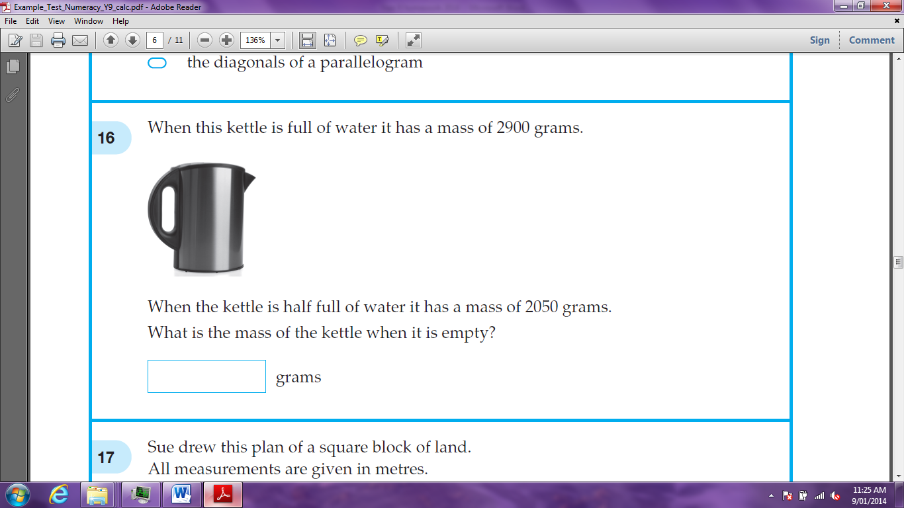
- When this kettle is full of water it has a mass of 2900 grams. When the kettle is half full of water it has a mass of 2050 grams. What is the mass of the kettle when it is empty?

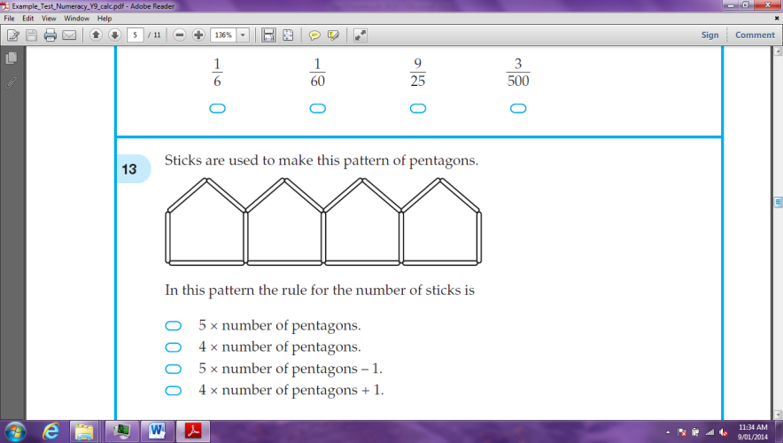
- Sticks are used to make this pattern of pentagons.




In this pattern the rule for the number of sticks is:

5 x number of pentagons 4 x number of pentagons
4 x number of pentagons - 1 4 x number of pentagons + 1

- A model of how a shell grows can be made using enlarged copies of the same triangle. Here is a model.
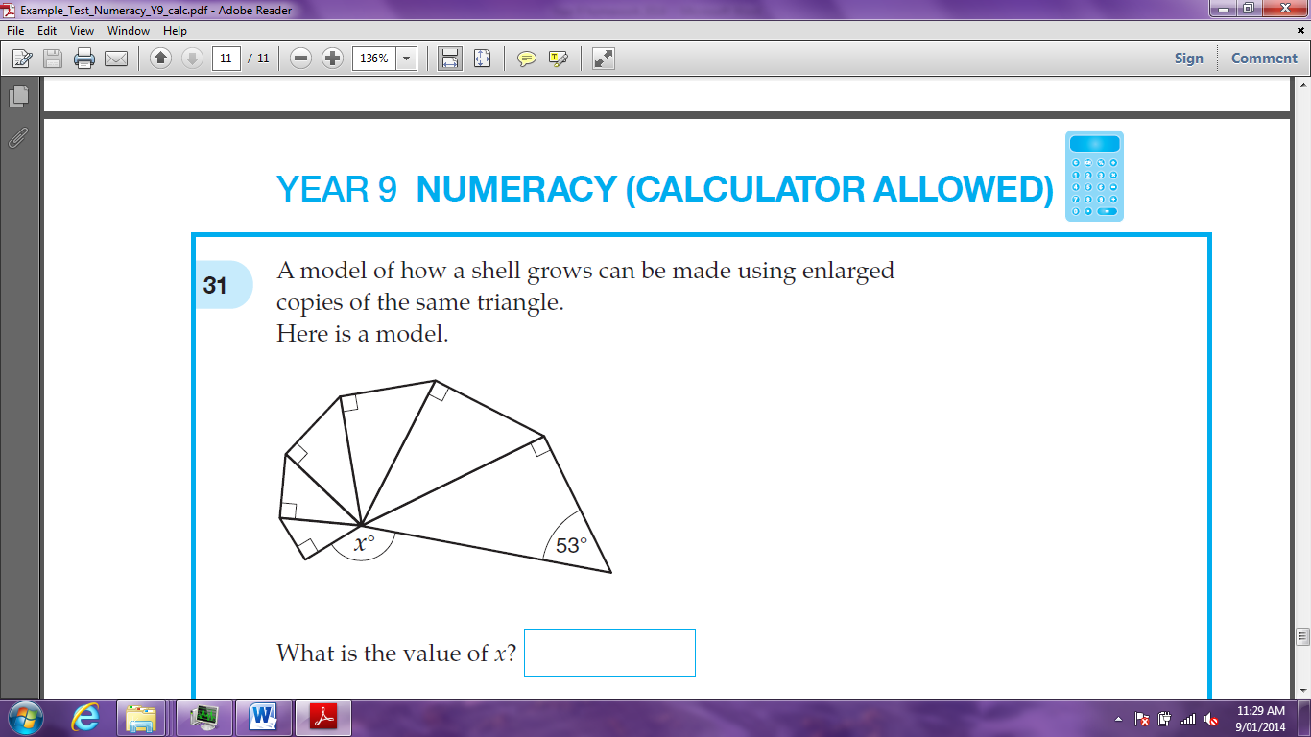

What is the value of x?

- Each of the angles of a regular polygon is 140°. How many sides does the polygon have?

